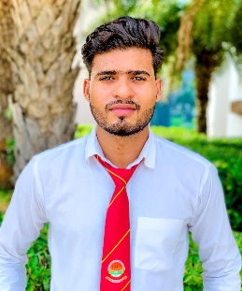 Junaid Husain

**+918958145220 , +918941804006 | Vill Mundia Kalan Rampur l, Uttar Pradesh** [**junaidhusain2628@gmail.com**](mailto:junaidhusain2628@gmail.com)

**https://www.linkedin.com/in/junaid-husain-a42b56201**

# SUMMARY

As a fresher with intermediate experience in analyzing, designing, and transforming software, I bring proficiency in HTML, CSS and JavaScript. I am a team player and a highly motivated individual, eager to learn new technologies and methodologies in software engineering. I am adept at adapting to different work cultures and thrive on accepting new challenges.

# SKILLS

* HTML
* CSS
* JavaScript
* Java
* SQL



# Projects

1. **Car Rent Management System**

The car rental management system is a comprehensive solution designed to streamline the process of renting vehicles. It offers an intuitive interface for both customers and rental company staff, allowing for easy reservation, tracking, and management of car rentals. Users can browse available vehicles, check availability based on dates and locations, and make reservations online. The system automates tasks such as vehicle check-in/out, payment processing, and generating rental agreements, reducing administrative burden and potential errors. Additionally, it provides tools for fleet management, including maintenance scheduling and tracking vehicle usage and performance.

1. **E – Commerce Website**

The website is an online platform offering a variety of products including shirts, cosmetics, and jeans. Developed using HTML and CSS, it provides a user-friendly interface for customers to browse and purchase items. The layout is designed to be visually appealing and easy to navigate, with clear categories for each type of product. Visitors can explore the latest trends in fashion, view detailed product descriptions, and make secure transactions.

# Education Background

1. Bachelor of Technology in Computer Science, 2021 – 2024 Teerthanker Mahaveer University, Moradabad Uttar Pradesh
2. Diploma in Computer Science Engineering , 2018 - 2021

Teerthanker Mahaveer University Moradabad, Uttar Pradesh

1. Intermediate,2020

Govt. Inter College Kemri, Rampur Uttar Pradesh

1. Matriculation,2016

K R Rajpoot I C Manpur, Bareilly Uttar Pradesh



**CERTIFICATIONS**

* Learning MEARN Stack with Certificate from 30days coding.com
* Cyber Security Certificate by Ministry of Electronics & Info. Technology.
* Training in HTML Certificate by Spoken Tutorial Project IIT Bombay.
* Python Basic in Data Science Certificate by Next Tech Innovation.
* Certificate in Managing self by Centre for Teaching Learning and Development (CTLD) Teerthanker Mahaveer University, Moradabad.
* Certificate in PHP by Aptron Solution Pvt. Ltd